Exp 9
clc;
clear;
close all;

% Continuous-Time LTI System: dy(t)/dt + 2y(t) = x(t)
% Assume zero initial conditions: H(s) = Y(s)/X(s) = 1/(s + 2)

num = [1];
den = [1 2];
sys = tf(num, den);

disp('Transfer function:');
sys

disp('Pole:');
disp(pole(sys));

disp('Zeros:');
disp(zero(sys));

t = 0:0.01:5;

% Impulse Response
figure;
impulse(sys, t);
grid on;
title('Impulse Response');
xlabel('Time (s)');
ylabel('h(t)');

% Step Response
figure;
step(sys, t);
grid on;
title('Step Response');
xlabel('Time (s)');
ylabel('y(t)');

% Response to x(t) = sin(2t)u(t)
x = sin(2*t);

figure;
lsim(sys, x, t);
grid on;
title('Response to sin(2t)u(t)');
xlabel('Time (s)');
ylabel('y(t)');
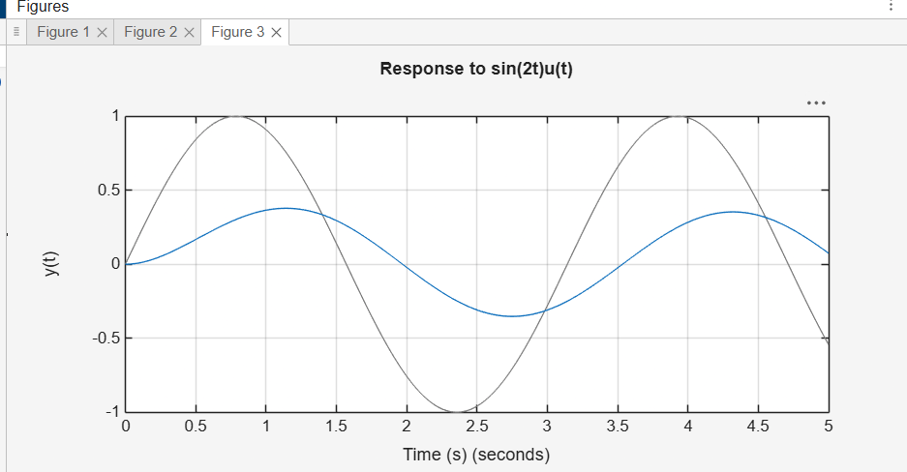

Exp 10
Exp clc;
clear;
close all;

% Experiment 10: Zero-input, zero-state, impulse response and convolution
% System: dy(t)/dt + 2y(t) = x(t)

t = 0:0.01:5;
dt = t(2)-t(1);

num = [1];
den = [1 2];

disp('Transfer function: H(s) = 1/(s+2)');
disp('Pole:');
disp(-2);

% Impulse response
h = exp(-2*t);

figure;
plot(t,h,'LineWidth',1.5);
grid on;
title('Impulse Response h(t)');
xlabel('Time (s)');
ylabel('h(t)');

% Zero-input response: y(0-) = 1
y_zi = exp(-2*t);

figure;
plot(t,y_zi,'LineWidth',1.5);
grid on;
title('Zero-Input Response');
xlabel('Time (s)');
ylabel('y_{zi}(t)');

% Unit-step input
x = ones(size(t));

% Zero-state response
y_zs = 0.5*(1-exp(-2*t));

figure;
plot(t,x,'--',t,y_zs,'LineWidth',1.5);
grid on;
legend('Input x(t)','Output y_{zs}(t)','Location','best');
title('Unit-Step Input and Zero-State Output');
xlabel('Time (s)');
ylabel('Amplitude');

% Numerical convolution
y_conv_full = conv(x,h)*dt;
y_conv = y_conv_full(1:length(t));
y_conv = y_conv - 0.5*dt*(x(1)*h + x*h(1));

% Total response
y_total = y_zi + y_zs;

figure;
plot(t,y_zi,t,y_zs,t,y_total,'LineWidth',1.3);
grid on;
legend('Zero-input','Zero-state','Total response','Location','best');
title('Comparison of Response Components');
xlabel('Time (s)');
ylabel('Response');

% Convolution verification
figure;
plot(t,y_conv,'--',t,y_zs,'-','LineWidth',1.5);
grid on;
legend('Convolution output','Theoretical output','Location','best');
title('Convolution Verification');
xlabel('Time (s)');
ylabel('y_{zs}(t)');
```